**Project One - Analysis of song popularity and pattern analysis in the audio files of popular songs.**

1. Team Name: (F) Data Pirates
2. Members: Alex Stanley, Jeni Arulraj, Ramyaa Vivek
3. Data Sources: Billboard Hot 100 and Spotify API
4. Some of the Spotify Audio features that we used for our analysis,
5. Danceability - It represents how a track is danceable based on tempo, rhythm stability, beat strength, and overall regularity. 0.0 is least danceable and 1.0 is most danceable.
6. Valence - 0.0 is a measure of low valence and 1.0 is a measure of high valence. Valence describes the musical positiveness of a track. Tracks with high valence are more positive (e.g. happy, cheerful, euphoric), while tracks with low valence are more negative (e.g. sad, depressed, angry).
7. Popularity - Represents how a track is popular based on various musical elements including danceability, valence, energy, duration, mode, loudness, tempo, speechiness, liveness, key etc.
8. Energy - 0.0 is a measure of low energy and 1.0 is a measure of high energy. Energetic tracks sound fast, loud, and noisy. For example, death metal has high energy, while a Bach prelude scores low on the scale. Perceptual features contributing to this attribute include dynamic range, perceived loudness, timbre, onset rate, and general entropy.
9. Duration - The duration of the track in milliseconds.
10. Mode - Mode indicates the modality (major or minor) of a track, the type of scale from which its melodic content is derived. Major is represented by 1 and minor is 0.
11. Loudness - The overall loudness of a track in decibels (dB). Loudness values are useful for comparing relative loudness of tracks. Loudness is the quality of a sound that is the primary psychological correlate of physical strength (amplitude). Values typical range between -60 and 0 db.
12. Tempo - The overall estimated tempo of a track in beats per minute (BPM). In musical terminology, tempo is the speed or pace of a given piece and derives directly from the average beat duration.
13. Questions we asked?
14. Is Country music more popular than Rap? (T-test for popularity)

Null Hypothesis (H0): No popularity difference between Country & Rap music

Alternate Hypothesis (H1 or Ha): There is difference in popularity b/w Country & Rap music

T-test Result: P-value = 6.14946668928311e-17

Decision: Since P-value < 0.05, we reject H0. Hence, there is difference in popularity b/w Country and Rap music.

1. Valence: Country music vs Hot-100 vs Rap music (Anova for valence).

Null Hypothesis (H0): No difference in Valence b/w Country, Rap music & Hot 100

Alternate Hypothesis (H1 or Ha): There is difference in valence b/w Country, Rap music & Hot 100

T-test Result: P-value = 0.0004471337243690721

Decision: Since P-value < 0.05, we reject H0. Hence, there is difference in valence b/w Country, Rap music and Hot-100

1. Danceability: Country music vs Hot-100 vs Rap music (Anova for Danceability).

Null Hypothesis (H0): No difference in Danceability b/w Country, Rap music & Hot 100

Alternate Hypothesis (H1 or Ha): There is difference in Danceability b/w Country, Rap music & Hot 100

T-test Result: P-value = 1.6941337881835844e-13

Decision: Since P-value < 0.05, we reject H0. Hence, there is difference in Danceability b/w Country, Rap music and Hot-100

1. **Key observations based on Scatter plot charts:**
2. Popularity vs Valence – Hot-100 and Rap music is more popular than Country music. However, Country music seems to have more positive vibe than Hot-100 and Rap music.
3. Popularity vs Danceability – Danceability is directly related to popularity of songs. Rap music is most popular and also danceable followed by Hot-100 and then Country music.
4. Popularity vs Energy – Although Country music is less popular than Hot-100 and Rap music, it appears to be most energetic compared to the other two genres.
5. **Key observations based on Bar charts:**
6. Danceability vs Genre - Among songs of top artists, Rap music is the most danceable genre followed by Hot-100 and then Country music.
7. Valence vs Genre - Among songs of top artists, Country music is the most positive genre followed by Rap music and then Hot-100.
8. **Key observations based on Regression Analysis:**
   1. Danceability is the most positive correlated feature to popularity.
   2. With the given top 100 songs, only 49% of the dataset participated in the linear regression.
   3. Prediction had 0.4 success rate.
9. **Final take:** If Country music is more danceable, it could be more popular too!!!

**Supplemental Analysis and Next Steps**

We had a high-level scope for the audio analysis for this project, but the Spotify API audio analysis is capable of very granular analysis of each song. While there isn’t much official documentation for it, we were able to explore some of the detailed analysis.

The audio segments analysis analyzes the audio file and gives pitch, timbre, and time data for each perceived “musical event.” This is basically a note by note analysis of the song’ as such, the JSON responses for the audio segments are huge, so Spotify limits developers to querying one song at a time.

We wrote code to measure the Euclidian distance from the timbre vectors of one “musical event” to the next. This is a way of mathematically representing how different the sounds in a song are from each other and gives insight into the complexity of a song. For instance, there is a striking difference in complexity in the genre-defying progressive bluegrass tune “All Ashore,” featuring constant shifts in instrumental solos and vocals, compared to the country pop hit, “Simple.” This difference is visualized in the charts below(Figure 1). Quantifying and analyzing this audio data could be fed into a machine learning model to aid in music composition.

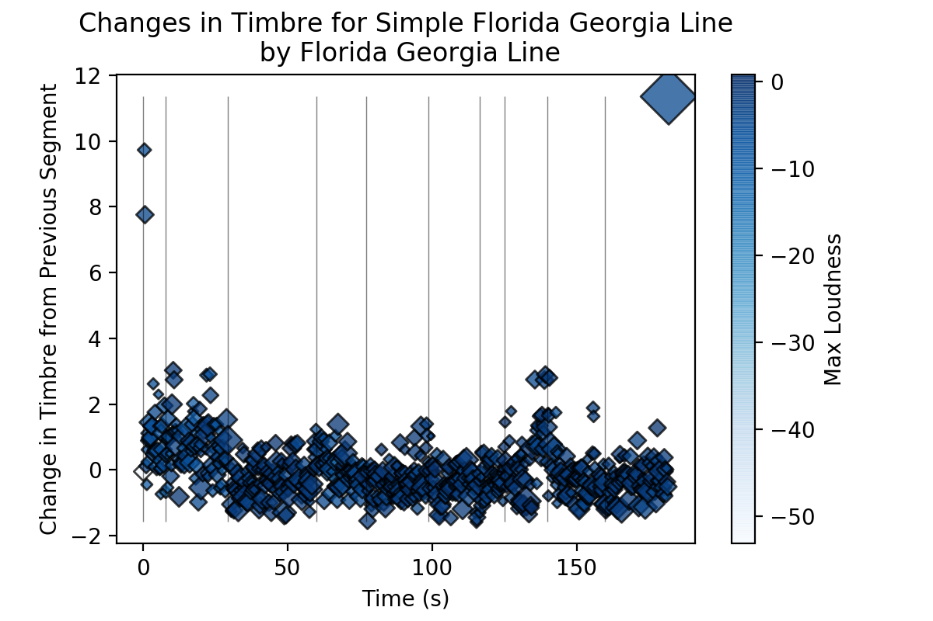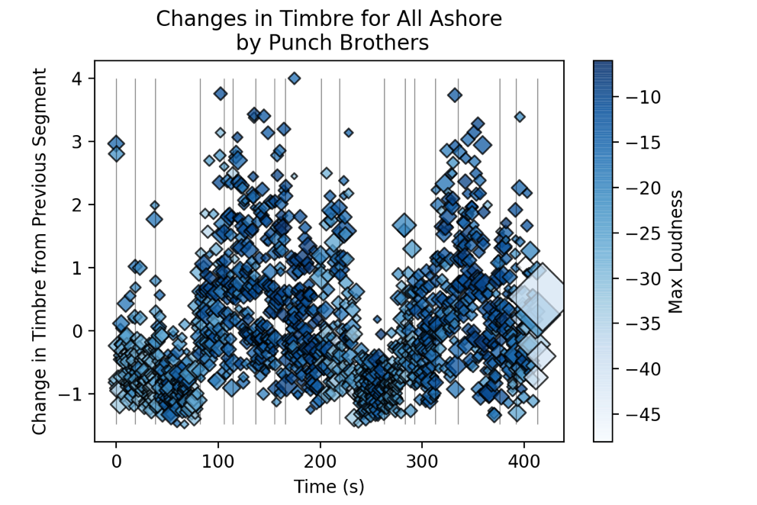

Figure : Data visualization of a simple song (top) vs a complex song (bottom)